THE PLACE-NAMES OF

MALDON All Saints and St Mary

Recorder: James Kemble

Essex Place-names Project (Essex Society for Archaeology & History), 2013 (e-book).

www.essex.ac.uk/history/esah/essexplacenames

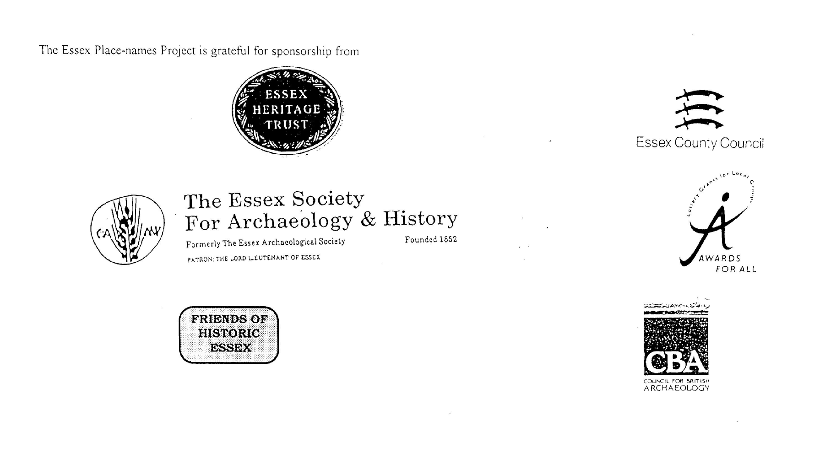

ESSEX PLACE-NAMES PROJECT.

The Essex Place-names Project is a County-wide survey to record place- and field-names from historical documents such as Tithe maps and apportionments, estate maps, sale
and auction catalogues, conveyances, terriers, deeds, rolls, inquisitions and surveys.

The second element of the Project is to investigate on-the-ground visible remains which correspond to the Place-names for actual or potential archaeological, agricultural and industrial
sites, and to record natural (topographical) and man-made features which may relate to the Place-name. This involves field-survey in rural and outside investigation in built-up areas.

It is anticipated that the Project will lead to identification of archaeological sites and lost historic buildings; it will enable analysis of indicators of early settlement, land holding, agricultural and industrial practices of the County. It will refine the more precise meaning of descriptive words and elements used by earlier settlers as they gave names appropriate to the topography of the landscape of their time.

For convenience the surveys are based on the parish, recognising that present civil parish boundaries are not necessarily identical to former ecclesiastical boundaries. Local Recorders
are supplied with templates of Record Forms to ensure consistency of recording across the County, and forward completed forms to a Central Coordinator for transfer to a county
computer database which is available to researchers on the internet at www.essex.ac.uk/history/esah/essexplacenames, and updated periodically.

This publication presents part of the information recorded from the Tithe or Estate Award and Map, and from other documents for this parish. The full record is contained on the master
database at Essex County Council (Historic Environment Section) and on the (above) website. Parish books are available to be downloaded from the website link ‘Books’ on the Home page. Please notify errors to the Project Coordinator at the Essex Record Office.

THE TITHE MAP AND APPORTIONMENT.

Since medieval times a tenth of the produce of land and stock had been paid by landholders to the church. At the Dissolution of the Monasteries, the property of many religious houses,
including the right to collect tithes, passed into lay hands. The Tithe Commutation Act which received Royal assent on 13th August 1836 abolished a rent payable in kind and
substituted rent-charges apportioned on each plot or parcel. The tithe-rent payable was assessed on the average value of wheat, barley and oats and was to fluctuate with price movements.

The commutation could be by voluntary agreement between the local owners and payers or, if agreement failed, could be compulsorily imposed by commissioners. A Valuer was to be
appointed to apportion the rent of each parcel of land and tenants could deduct that rent-charge from their rent paid to the landlord. The task fell to the Tithe Commissioners to produce a
map and an Apportionment (Award). A large-scale survey was produced for over 70% of England and Wales in the following 9 years, and about another 8% up to 1855. Most of the
parishes in Essex were surveyed. The map scales vary. The Award records ownership, tenancy and land-use, field by field and parcel by parcel (often quoting the field name) with the
ground area and rent-charge.

Land that was tithe-free tends to be less accurately mapped and contains few if any of the details recorded for those parcels subject to tithe. Rights of way and roads also tend to be
neglected. Boundaries of the tithe areas are shown as are some natural features such as streams, ponds, gardens, greens and commons. Buildings are often shown coloured red if dwellings
or grey if not. Because the Award may have been agreed only some time after the map was finished, discrepancies occur between the two. Enclosure Awards, when extant, usually date to the 18th and early 19th centuries. J.Kemble.
Reproduced by permission
of Essex County Council.

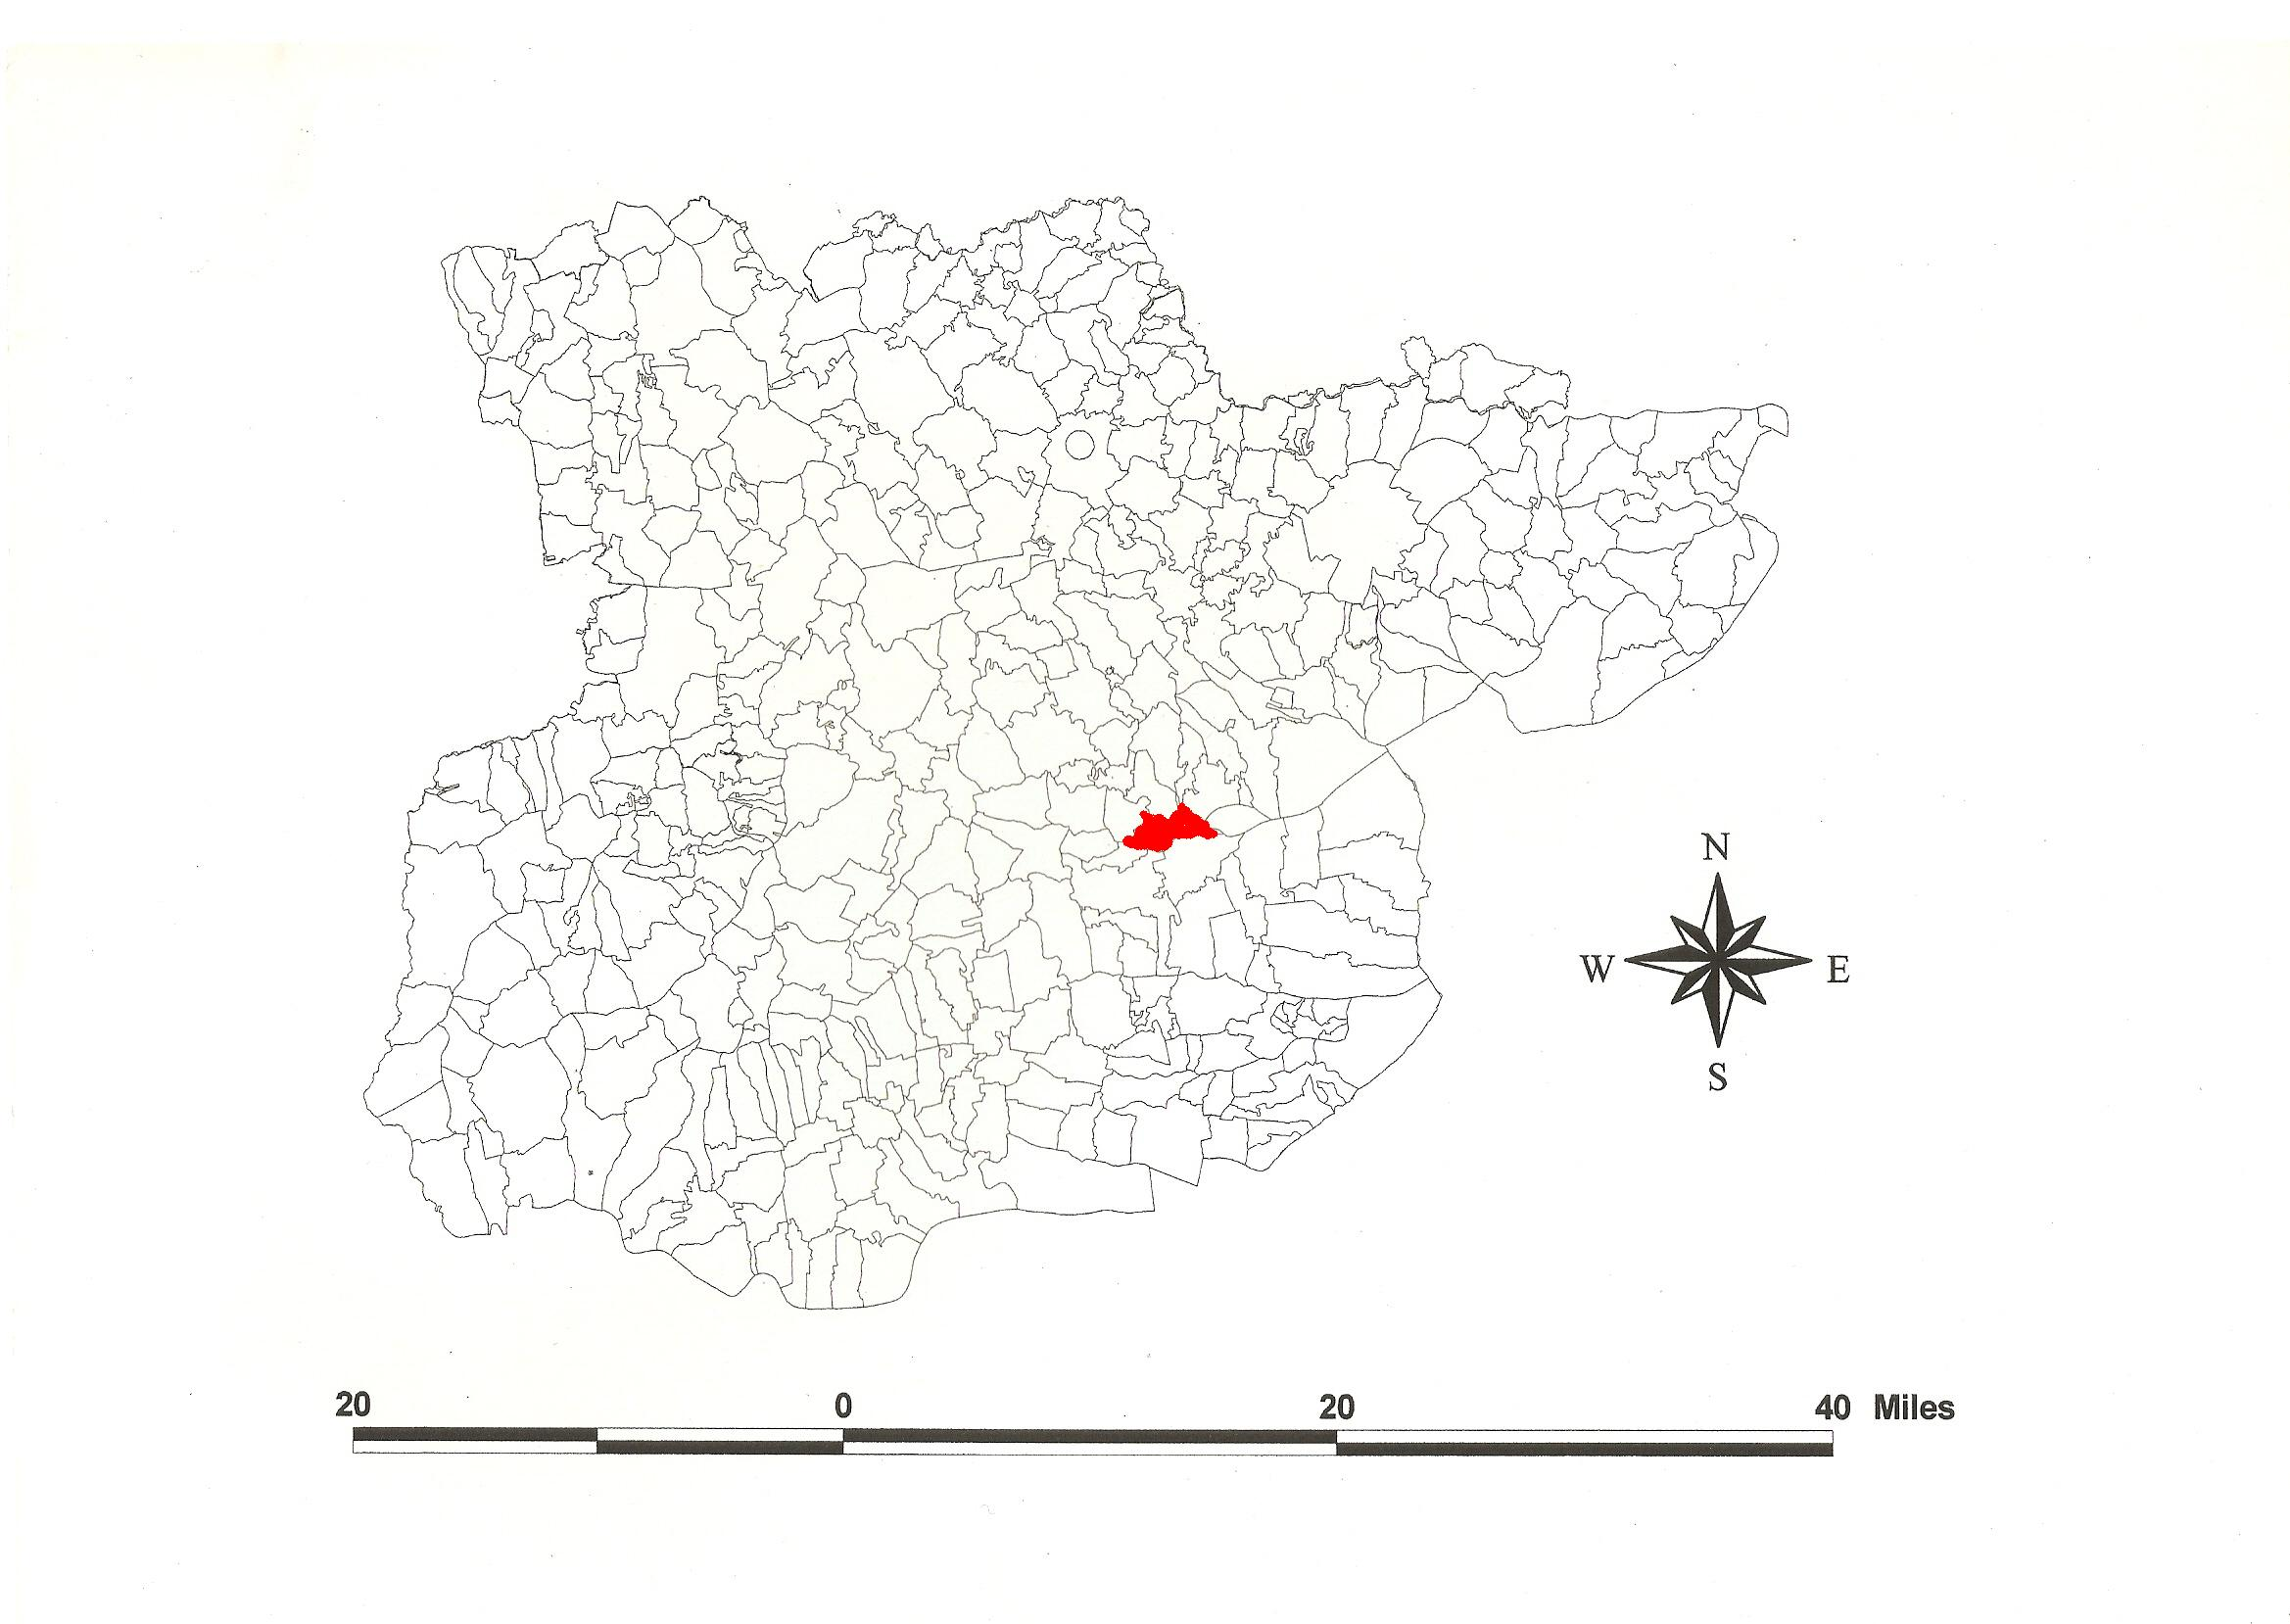
Reproduced by permission of
Essex County Council.
Maldon All Saints & St Mary Parishes in the County of Essex.
The Parishes of Maldon All Saints and St Mary (in Dengie alias Witbrictesherna Hundred).

The Tithe Award of Maldon All Saints (Essex Record Office D/P 207/17/1), dated 1848, shows a rent-charge payable to the trustees of the late John Hance £3 for 6 acres 12 perches, to George French £8 for 19 acres 1 rood 23 perches, to Edward Bright £1-15-0 for 3a 2r 27p, and to the Vicar £25-17-0 for the residuum. The whole parish measured 64 acres 2 roods 20 perches of which 9 acres 1 rood 38 perches were arable, 10a 2r 15p meadow and pasture, 1a 1r 36p plantations, 23a 11p gardens and 20 acres buildings and roads. The Tithe Commissioners were William Blamire and R. Jones, the Valuer William Bulley of Maldon. The Tithe Map (ERO: D/P 207/17/2 (D/CT 226b)) was surveyed at a scale of 1” to 1 chain [1:792].

The Tithe Award of Maldon St Mary (Essex Record Office D/CT 227a), dated 1843, shows a rent-charge of £270 payable to the perpetual curate. 427 acres 2 roods 38 perches of land of the Dean & Chapter of Westminster were tithe exempt. 920 acres 29 perches were titheable, 424a 2r 16p were arable, 319a 3r 7p meadow and pasture, 15a 3r 20p sea wall, 111a 13p saltings, 3a 2r 36 wood, 34a 1r 37p buildings, 10a 2r 20p roads and waste. The Tithe Commissioners were William Blamire and J.W. Buller, the Assistant Thomas James Tatham, and the Valuer J. Robert Baker of Writtle. The Tithe Map (ERO: D/CT 227b) was surved at a scale of 4 chains to an inch (20” to a mile) and measures 47”x66”. It was countersigned by G.H. Whalley, Assistant Tithe Commissioner.

At Mældune, King Edward encamped before engaging the Danish army in 909. The traditional site of the Battle of Maldon, in 991, is on the fields west of the causeway from Northey
Island (Cooper, 1993). In Domesday Book, 1086, the king had a house and pasture for 100 sheep at Melduna. From him, burgesses had 180 houses (Powell, 1997, 2000). The church at Mealdone with 2 hides was confirmed to St Martin le Grand, London, by William I in 1068 (Hart, 1971). Carseia(m) alias Northey Island was held by Richard from Hamo the Steward which Thorburn, a free man, had held before 1066 as a manor for 4 hides 40 acres (Morris, 1983). Great (King’s) Maldon included most of the Town. In 1173 it was alienated to Oliver fitzErnest. The bishop of London held it in demesne until 1403. In 1503, St Martin le Grand with St Mary were granted to Westminster Abbey (Morant, 1768; Round, 1995). On the tower was a sea-mark. Maldon is translated from Old English mael dun, ‘hill with a cross’, probably a reference to an early preaching site (Petchey, 1991; Kemble, 2007).

At Maldon an unenclosed settlement of the 6th century BC overlooking the Blackwater valley was later surrounded by a timber pallisade. The circuit of the Iron Age fort can be traced at Spital Street and Dykes Chase. All Saints church has a C13th triangular west tower. St Mary at The Hythe has a Norman window in the north nave wall. Moot Hall in High Street was built for Sir Robert Darcy in the 1420s. The Plume Library, Market Hill, was built c.1698, the site of St Peter’s church, its C15th west tower extant. St Giles Leper Hospital, Spital Road, was founded in 1164 (Pevsner, 2007; Kemble, 2009).

The Hundred name Danesie (documented in 1185) was preceded by a charter of King Suebred of the East Saxons who granted 70 cassati (hides) in regio Deningei to the Bishop of London in 706x709 (Hart, 1971). Watts (2004) suggests this derives from a personal name Dæni + eg, ‘island’ or ‘island called after Dæni’. Reaney (1935) prefers to associate O.E. dænn, ‘woodland pasture for swine’. He allows that this area was once occupied by the Dænningas tribe. The Domesday Book (1086) name of the Hundred was Witbrictesherna, Wibrictesherna, which Reaney (1935) translates from a personal name + hyrne, ‘Whitbeorht’s corner’, referring to the topography of the peninsula. Christie (1926) places the moot at Lawling in Latchingdon which was held by ealdorman Brithnoth who was killed at the Battle of Maldon in 991 (Kemble, 2009a).

References:

Christie, M., 1926. Essex Hundred Moots. Trans Essex Arch. Soc., n.s.,
xviii (3), 183.
Cooper, J. (ed), 1993. The Battle of Maldon, Fact or Fiction. Hambledon.
Hart, C., 1971. Early Charters of Essex, Leicester.
Kemble, J., 2007. Essex Place-names, Places, Streets & People. Historical Publications,
Kemble, J., 2009. Prehistoric & Roman Essex. History Press, Stroud.
Kemble, J., 2009a. The Place-names of Latchingdon cum Lawling.
www.essex.ac.uk/history/esah/essexplacenames. Then click on ‘Books’.
Morant, P., 1768. History & Antiquities of the County of Essex, i, 333, 334.
Morris, J., 1983. Domesday Book – Essex. Phillimore.
Petchey, W.J., 1991. A Prospect of Maldon.
Pevsner, N., Bettley, J., 2007. Buildings of England – Essex. Yale. p578.
Powell, W.R., 1997. Maldon & St Martins. Essex Arch. Hist., 28, 142.
Powell, W.R., 2000. Manors of Maldon. Essex Arch. History, 31, 147.
Reaney, P., 1935. Place-names of Essex. Cambridge.
Round, J.H., 1995. Maldon. Essex Archaeology & History, 26, 162.
Victoria County History of Essex, 1903, i, 393.

The Tithe Award Place-names of Maldon All Saints - by parcel no.

Place-name | Alias | Fld No | Grd Rf | x | y | Type | Acr | rd | pch | Land use | Owner | Occupier
Garden |  | 1 | TL | 846 | 076 |  | 0 | 3 | 36 |  | Dyke, Harriet | Dyke, Harriet
Arable |  | 2 |  |  |  | field | 0 | 2 | 16 | Arable | Burls, Robert | Burls, Robert
Garden, bldgs |  | 3 | TL | 847 | 076 | bldg | 0 | 1 | 9 |  | Sadd, John | Harland, Thos; Poole, Richard
Orchard |  | 7 |  |  |  |  | 1 | 0 | 28 |  | Pitcairn, John | Pitcairn, John
Pasture |  | 8 |  |  |  | field | 0 | 0 | 31 | pasture | Pitcairn, John | Pitcairn, John
Gardens, bldgs, Chase |  | 10,11 |  |  |  | bldg | 0 | 1 | 21 |  | Marriage, James | Hudson, James; Maynard; others
Garden, bldg |  | 15 |  |  |  | bldg | 0 | 0 | 19 |  | Shoobridges, execs | Shynn, John
Garden, bldgs, yard |  | 19 |  |  |  | bldg | 0 | 0 | 14 |  | Sandles, execs | Tomlinson, James
Garden, bldgs |  | 20,21 |  |  |  | bldg | 0 | 1 | 21 |  | Clapton, John | Clapton, John; Knight, Joseph
Garden, House |  | 24 |  |  |  | bldg | 0 | 0 | 14 |  | Bickmore, Robert | Wilmshurst. Ann
Pasture |  | 26 |  |  |  | field | 0 | 1 | 5 | pasture | Pepper, Henry | Pepper, Henry
House, yard |  | 30 |  |  |  | bldg | 0 | 0 | 8 |  | Angier, William | Tunmer, Elston, Rogers, John
Arable |  | 35 |  |  |  | field | 1 | 3 | 7 | arable | French, George | French, George
Arable |  | 37 |  |  |  | field | 0 | 2 | 13 | arable | Bright, Edward | Bright, Edward
Garden, bldg |  | 40 |  |  |  | bldg | 0 | 0 | 7 |  | Wentworth, trustees | Angier, William
Pasture |  | 43 |  |  |  | field | 1 | 0 | 7 | pasture | Bright, Edward | Bright, Edward
Homestead |  | 45 |  |  |  | bldg | 0 | 0 | 8 |  | Bright, Edward | Bright, Edward
Pasture |  | 49 |  |  |  | field | 3 | 0 | 4 | pasture | Thorp, John | Thorp, John
Arable |  | 51 |  |  |  | field | 2 | 1 | 37 | arable | French, George | French, George
Homestead |  | 54 |  |  |  | bldg | 0 | 0 | 24 |  | French, George | French, George
Pasture |  | 58 |  |  |  | field | 0 | 2 | 7 | pasture | Sadd, Daniel | Battle, Turnbridge
Buildings, yard |  | 60 |  |  |  | bldg | 0 | 1 | 7 |  | Pitcairn, John | Pitcairn, John
Garden, bldg |  | 65 | TL | 848 | 071 | bldg | 0 | 0 | 24 |  | Bygrave, George | Rickards, James B
Garden, bldgs, yd |  | 70 |  |  |  | bldg | 0 | 0 | 10 |  | Digby, George Wyatt | Reynolds, Robert
Buildings, yards |  | 75 |  |  |  | bldg | 0 | 0 | 7 |  | Busbridge, Alfred | Huxter, John; others
Garden, bldgs |  | 80 |  |  |  | bldg | 0 | 0 | 10 |  | Wells, Wm Collings; Perry, Isaac | Hearn, William
Garden |  | 85 |  |  |  |  | 2 | 0 | 20 |  | Clapton, Sarah | Stratford, James
Garden, bldgs |  | 90 |  |  |  | bldg | 0 | 0 | 7 |  | Bygrave, Thomas | Ashley, James; Cornell, John
Buildings, yard |  | 95 |  |  |  | bldg | 0 | 0 | 10 |  | Pretty, John | Pretty, John
Garden |  | 100 |  |  |  |  | 0 | 0 | 11 |  | Bruce, Thomas | Bruce, Thomas
Buildings, yard |  | 105 |  |  |  | bldg | 0 | 0 | 13 |  | Polley, John | Brown, Robert; others
All Saints Church, yard |  | 106 | TL | 849 | 071 |  | 0 | 1 | 20 |  | .. | ..
Town Hall |  | 111 | TL | 815 | 070 | bldg | 0 | 0 | 5 |  | .. | ..
Building, yard |  | 115 |  |  |  | bldg | 0 | 0 | 9 |  | Jay, Thomas | Jay, Thomas
Buildings, yard |  | 120 |  |  |  | bldg | 0 | 0 | 7 |  | Raymond, Thomas | Raymond, Thomas
Plantation, bldgs |  | 124 |  |  |  | bldg | 0 | 0 | 27 |  | Prior, Rev John Laurence | Dunn, Rev S
Garden |  | 130 |  |  |  |  | 0 | 0 | 12 |  | Hardcastle, Alfred | Cottee, Reuben
Garden |  | 135 |  |  |  |  | 0 | 0 | 25 |  | Smith, Robert | Smith, Robert
Garden |  | 140 |  |  |  |  | 0 | 1 | 26 |  | Wedd, Mary | Hicks, Philip
Garden |  | 145 |  |  |  |  | 0 | 2 | 12 |  | Mays, execs | May, Henry
Ornamental Grounds |  | 147 |  |  |  |  | 0 | 3 | 1 |  | Driffield, Charles | Prior, Andrew; Mrs Grimwood
Garden, bldgs |  | 150 |  |  |  | bldg | 0 | 0 | 19 |  | Parkers execs | Beckwith; others
Garden, building |  | 151 |  |  |  | bldg | 0 | 0 | 4 |  | Payne, James | Beckwith; others
Garden, building |  | 153 |  |  |  | bldg | 0 | 0 | 10 |  | Brewster, Joseph | Brewster, Joseph
Plantation, bldgs |  | 155 |  |  |  | bldg | 0 | 2 | 12 |  | Dyke, Harriet | Dyke, Harriet
Garden, bldgs, yd |  | 157 |  |  |  | bldg | 0 | 0 | 8 |  | Pepper, Henry | Pepper, Henry
Plantation |  | 160 |  |  |  | pltn | 0 | 0 | 26 |  | Digby, George Wyatt | Digby, George Wyatt
House, yard |  | 163 |  |  |  | bldg | 0 | 0 | 15 |  | Crick, John | Crick, John
Buildings, yard |  | 165 |  |  |  | bldg | 0 | 0 | 15 |  | Bygrave, George | Rickards, James B
Building, yard |  | 167 |  |  |  | bldg | 0 | 0 | 5 |  | Blythe, Dorcas | Blythe, Dorcas
Buildings, yard |  | 170 | TL | 850 | 075 | bldg | 0 | 0 | 22 |  | Wilmshurst, John | Butler, James
Buildings, yard |  | 171 |  |  |  | bldg | 0 | 0 | 12 |  | Tomlinson, James | Tomlinson, James
Buildings, yard |  | 173 |  |  |  | bldg | 0 | 0 | 5 |  | Bruce, Thomas | Bruce, Thomas
Buildings, yard |  | 176 |  |  |  | bldg | 0 | 0 | 6 |  | Jay, Thomas | Jay, Thomas
Buildings, yards |  | 177 |  |  |  | bldg | 0 | 0 | 27 |  | Bygrave, John Augustine | Bygrave, John Augustine
Plantation |  | 178 |  |  |  | pltn | 0 | 0 | 7 | pltn | Allaker, William | Codd, William
Plantation |  | 180 |  |  |  | pltn | 0 | 2 | 20 | pltn | Mays, execs | May, Henry
Buildings, yard |  | 185 |  |  |  | bldg | 0 | 0 | 23 |  | Wedd, Mary | Wedd, Mary
House, yard |  | 186 |  |  |  | bldg | 0 | 0 | 20 |  | Driffield, Charles | Prior, Andrew; Mrs Grimwood
Garden |  | 187 |  |  |  |  | 0 | 2 | 20 |  | Wentworth, trustees | Harvey, Henry

The Tithe Place-names of Maldon All Saints - by Owner.

Place-name | Alias | Fld No | Grd Rf | x | y | Type | Acr | Rd | pch | Land use | Owner | Occupier
All Saints Church, yard |  | 106 | TL | 849 | 071 |  | 0 | 1 | 20 |  | .. | ..
Town Hall |  | 111 | TL | 851 | 070 | bldg | 0 | 0 | 5 |  | .. | ..
Plantation |  | 178 |  |  |  | pltn | 0 | 0 | 7 | pltn | Allaker, William | Codd, William
House, yard |  | 30 |  |  |  | bldg | 0 | 0 | 8 |  | Angier, William | Tunmer, Elston, Rogers, John
Garden, House |  | 24 |  |  |  | bldg | 0 | 0 | 14 |  | Bickmore, Robert | Wilmshurst. Ann
Building, yard |  | 167 |  |  |  | bldg | 0 | 0 | 5 |  | Blythe, Dorcas | Blythe, Dorcas
Garden, building |  | 153 |  |  |  | bldg | 0 | 0 | 10 |  | Brewster, Joseph | Brewster, Joseph
Arable |  | 37 |  |  |  | field | 0 | 2 | 13 | arable | Bright, Edward | Bright, Edward
Pasture |  | 43 |  |  |  | field | 1 | 0 | 7 | pasture | Bright, Edward | Bright, Edward
Homestead |  | 45 |  |  |  | bldg | 0 | 0 | 8 |  | Bright, Edward | Bright, Edward
Garden |  | 100 |  |  |  |  | 0 | 0 | 11 |  | Bruce, Thomas | Bruce, Thomas
Buildings, yard |  | 173 |  |  |  | bldg | 0 | 0 | 5 |  | Bruce, Thomas | Bruce, Thomas
Arable |  | 2 |  |  |  | field | 0 | 2 | 16 | arable | Burls, Robert | Burls, Robert
Buildings, yards |  | 75 |  |  |  | bldg | 0 | 0 | 7 |  | Busbridge, Alfred | Huxter, John; others
Buildings, yard |  | 165 |  |  |  | bldg | 0 | 0 | 15 |  | Bygrave, George | Rickards, James B
Garden, bldg |  | 65 | TL | 848 | 071 | bldg | 0 | 0 | 24 |  | Bygrave, George | Rickards, James B
Buildings, yards |  | 177 |  |  |  | bldg | 0 | 0 | 27 |  | Bygrave, John Augustine | Bygrave, John Augustine
Garden, bldgs |  | 90 |  |  |  | bldg | 0 | 0 | 7 |  | Bygrave, Thomas | Ashley, James; Cornell, John
Garden, bldgs |  | 20,21 |  |  |  | bldg | 0 | 1 | 21 |  | Clapton, John | Clapton, John; Knight, Joseph
Garden |  | 85 |  |  |  |  | 2 | 0 | 20 |  | Clapton, Sarah | Stratford, James
House, yard |  | 163 |  |  |  | bldg | 0 | 0 | 15 |  | Crick, John | Crick, John
Plantation |  | 160 |  |  |  | pltn | 0 | 0 | 26 |  | Digby, George Wyatt | Digby, George Wyatt
Garden, bldgs, yd |  | 70 |  |  |  | bldg | 0 | 0 | 10 |  | Digby, George Wyatt | Reynolds, Robert
Ornamental Grounds |  | 147 |  |  |  |  | 0 | 3 | 1 |  | Driffield, Charles | Prior, Andrew; Mrs Grimwood
House, yard |  | 186 |  |  |  | bldg | 0 | 0 | 20 |  | Driffield, Charles | Prior, Andrew; Mrs Grimwood
Garden |  | 1 | TL | 846 | 076 |  | 0 | 3 | 36 |  | Dyke, Harriet | Dyke, Harriet
Plantation, bldgs |  | 155 |  |  |  | bldg | 0 | 2 | 12 |  | Dyke, Harriet | Dyke, Harriet
Arable |  | 35 |  |  |  | field | 1 | 3 | 7 | arable | French, George | French, George
Arable |  | 51 |  |  |  | field | 2 | 1 | 37 | arable | French, George | French, George
Homestead |  | 54 |  |  |  | bldg | 0 | 0 | 24 |  | French, George | French, George
Garden |  | 130 |  |  |  |  | 0 | 0 | 12 |  | Hardcastle, Alfred | Cottee, Reuben
Building, yard |  | 115 |  |  |  | bldg | 0 | 0 | 9 |  | Jay, Thomas | Jay, Thomas
Buildings, yard |  | 176 |  |  |  | bldg | 0 | 0 | 6 |  | Jay, Thomas | Jay, Thomas
Gardens, bldgs, Chase |  | 10,11 |  |  |  | bldg | 0 | 1 | 21 |  | Marriage, James | Hudson, James; Maynard; others
Garden |  | 145 |  |  |  |  | 0 | 2 | 12 |  | Mays, execs | May, Henry
Plantation |  | 180 |  |  |  | pltn | 0 | 2 | 20 | pltn | Mays, execs | May, Henry
Garden, bldgs |  | 150 |  |  |  | bldg | 0 | 0 | 19 |  | Parkers execs | Beckwith; others
Garden, building |  | 151 |  |  |  | bldg | 0 | 0 | 4 |  | Payne, James | Beckwith; others
Garden, bldgs, yd |  | 157 |  |  |  | bldg | 0 | 0 | 8 |  | Pepper, Henry | Pepper, Henry
Pasture |  | 26 |  |  |  | field | 0 | 1 | 5 | pasture | Pepper, Henry | Pepper, Henry
Buildings, yard |  | 60 |  |  |  | bldg | 0 | 1 | 7 |  | Pitcairn, John | Pitcairn, John
Orchard |  | 7 |  |  |  |  | 1 | 0 | 28 |  | Pitcairn, John | Pitcairn, John
Pasture |  | 8 |  |  |  | field | 0 | 0 | 31 | pasture | Pitcairn, John | Pitcairn, John
Buildings, yard |  | 105 |  |  |  | bldg | 0 | 0 | 13 |  | Polley, John | Brown, Robert; others
Buildings, yard |  | 95 |  |  |  | bldg | 0 | 0 | 10 |  | Pretty, John | Pretty, John
Plantation, bldgs |  | 124 |  |  |  | bldg | 0 | 0 | 27 |  | Prior, Rev John Laurence | Dunn, Rev S
Buildings, yard |  | 120 |  |  |  | bldg | 0 | 0 | 7 |  | Raymond, Thomas | Raymond, Thomas
Pasture |  | 58 |  |  |  | field | 0 | 2 | 7 | pasture | Sadd, Daniel | Battle, Turnbridge
Garden, bldgs |  | 3 | TL | 847 | 076 | bldg | 0 | 1 | 9 |  | Sadd, John | Harland, Thos; Poole, Richard
Garden, bldgs, yard |  | 19 |  |  |  | bldg | 0 | 0 | 14 |  | Sandles, execs | Tomlinson, James
Garden, bldg |  | 15 |  |  |  | bldg | 0 | 0 | 19 |  | Shoobridges, execs | Shynn, John
Garden |  | 135 |  |  |  |  | 0 | 0 | 25 |  | Smith, Robert | Smith, Robert
Pasture |  | 49 |  |  |  | field | 3 | 0 | 4 | pasture | Thorp, John | Thorp, John
Buildings, yard |  | 171 |  |  |  | bldg | 0 | 0 | 12 |  | Tomlinson, James | Tomlinson, James
Garden |  | 140 |  |  |  |  | 0 | 1 | 26 |  | Wedd, Mary | Hicks, Philip
Buildings, yard |  | 185 |  |  |  | bldg | 0 | 0 | 23 |  | Wedd, Mary | Wedd, Mary
Garden, bldgs |  | 80 |  |  |  | bldg | 0 | 0 | 10 |  | Wells, Wm Collings; Perry, Isaac | Hearn, William
Garden, bldg |  | 40 |  |  |  | bldg | 0 | 0 | 7 |  | Wentworth, trustees | Angier, William
Garden |  | 187 |  |  |  |  | 0 | 2 | 20 |  | Wentworth, trustees | Harvey, Henry
Buildings, yard |  | 170 | TL | 850 | 075 | bldg | 0 | 0 | 22 |  | Wilmshurst, John | Butler, James

The Tithe Award Place-names of Maldon St Mary - by parcel no.

Place-name | Alias | Fld No | Grd Rf | x | Y | Type | Acr | Rd | pch | Land use | Owner | Occupier |  | Other information
House, premises, gdn |  | 1 |  |  |  | bldg | 0 | 2 | 35 |  | Crick, William | Heald, Wm & Frederick
House, premises, flower gdn |  | 2 | TL | 848 | 070 | bldg | 0 | 3 | 30 |  | May, George | May, George
Pasture |  | 5 |  |  |  | field | 0 | 2 | 26 | pasture | May, George | May, George
Garden |  | 10 |  |  |  |  | 0 | 2 | 1 |  | Goldstone, John | Stratford, William
House, gdn |  | 12 |  |  |  | bldg | 0 | 1 | 6 |  | Dunnett, John | Dunnett, John
Cottage, gdn |  | 13 |  |  |  | bldg | 0 | 0 | 7 |  | Dudley, Daniel | Fowler, Thomas
House, gdn |  | 15 |  |  |  | bldg | 0 | 1 | 20 |  | Dudley, Daniel | Herbert, Elizabeth
Cottage, gdn |  | 16 |  |  |  | bldg | 0 | 0 | 29 |  | Dudley, Daniel | Baxter, William
Church Piece |  | 17 | TL | 855 | 066 |  | 1 | 3 | 30 |  | Dean & Chapter Westminster | Hurrell, Charles |  | Tithe free
Shed, yard |  | 20 |  |  |  |  | 0 | 0 | 18 |  | Elliston, John | Elliston, John
Cottage, field |  | 22 | TL | 855 | 065 | bldg | 3 | 3 | 32 | arable | Wright, Charles & James | Wright, Charles & James
Cottages, gdns |  | 24 |  |  |  | bldg | 0 | 0 | 19 |  | Warren, Moses | Laythrop, Daniel; another
Cottages, Blacksmith's shop, gdn |  | 25 |  |  |  | bldg | 0 | 0 | 32 |  | Bourne, Francis; Bourne, John | Pretty, John; others
Channel Marsh |  | 27 | TL | 859 | 064 | field | 15 | 3 | 0 | pasture | Dean & Chapter Westminster | Hurrell, Charles |  | Tithe free
Cottage, gdn |  | 28a |  |  |  | bldg | 0 | 0 | 29 |  | Handley, Charles | Handley, Charles
Cottage, Baths, Fish Pits |  | 29 | TL | 861 | 064 | bldg | 3 | 2 | 18 |  | Handley, John | Handley, John
Hither Rough Marsh |  | 30 | TL | 862 | 063 | field | 19 | 1 | 10 | pasture | Dean & Chapter Westminster | Hurrell, Charles |  | Tithe free
Pond Marsh |  | 31 |  |  |  | field | 17 | 2 | 8 | pasture | Dean & Chapter Westminster | Hurrell, Charles |  | Tithe free
Primrose Marsh |  | 32 | TL | 858 | 061 | field | 22 | 1 | 30 |  | Dean & Chapter Westminster | Hurrell, Charles |  | Tithe free
Town field |  | 34 | TL | 852 | 059 | field | 16 | 1 | 2 | arable | Dean & Chapter Westminster | Hurrell, Charles |  | Tithe free
House, gdn |  | 35 |  |  |  | bldg | 0 | 1 | 15 |  | Sincocks, William | Finch, John
Cottage, gdn |  | 36 |  |  |  | bldg | 0 | 1 | 16 |  | Sincocks, William | Finch, John
Maldon field |  | 40 | TL | 849 | 058 | field | 18 | 1 | 2 | arable | Hutley, William | Stanes, Richard Creek
Seeley House Pightle |  | 42 |  |  |  | field | 3 | 1 | 3 | pasture | Christ's College, Cambridge | Hurrell, Charles
Homestead. [Silly House, 1875,OS; Seeleigh House, 1968,OS] | (le) Selyhous, 1357,HarlR; Salyhous,1486, EAS,os, iv | 43 | TL | 852 | 066 | bldg | 0 | 2 | 1 |  | Christ's College, Cambridge | Hurrell, Charles |  | O.E. sealh = willow
Groves field |  | 46 |  |  |  | field | 12 | 1 | 20 | arable | Dean & Chapter Westminster | Hurrell, Charles |  | Tithe free
Home mead |  | 47 |  |  |  | field | 8 | 2 | 30 | pasture | Dean & Chapter Westminster | Hurrell, Charles |  | Tithe free
Homestead, Chase | Brick House, 1777,C; Northey House, 1968,OS | 48 |  |  |  | bldg | 3 | 0 | 37 |  | Dean & Chapter Westminster | Hurrell, Charles |  | Tithe free
Middle Rough Marsh |  | 52 | TL | 864 | 062 | field | 10 | 3 | 33 | pasture | Dean & Chapter Westminster | Hurrell, Charles |  | Tithe free
LittleRough Marsh |  | 53 |  |  |  | field | 2 | 1 | 24 | pasture | Dean & Chapter Westminster | Hurrell, Charles |  | Tithe free
Saltings |  | 54 |  |  |  |  | 33 | 2 | 20 |  | Dean & Chapter Westminster | Hurrell, Charles |  | Tithe free
Sea Wall |  | 54a |  |  |  |  | 3 | 3 | 26 |  | Dean & Chapter Westminster | Hurrell, Charles |  | Tithe free
Further Rough Marsh |  | 56 | TL | 866 | 058 | field | 20 | 3 | 20 | pasture | Dean & Chapter Westminster | Hurrell, Charles |  | Tithe free
Twelve acres |  | 58 |  |  |  | field | 12 | 0 | 35 | arable | Johnson, Abraham | Skingley, Joseph & Charles
Spring Pond field |  | 63 | TL | 855 | 054 | field | 14 | 1 | 24 | arable | Dean & Chapter Westminster | Hurrell, Charles |  | Tithe free
Little Jenkins Marsh |  | 70 | TL | 855 | 047 | field | 4 | 3 | 10 | pasture | Dean & Chapter Westminster | Hurrell, Charles |  | Tithe free
Upper Graces (pt) |  | 72 | TL | 848 | 055 | field | 10 | 3 | 8 | arable | Hutley, William | Stanes, Richard Creek
Harts field (pt) |  | 75 | TL | 845 | 053 | field | 3 | 1 | 3 | arable | Hutley, William | Stanes, Richard Creek
Lower Hungry Downs |  | 77 | TL | 846 | 050 | field | 10 | 2 | 23 | arable | Hutley, William | Stanes, Richard Creek
Cottage, gdn |  | 79 |  |  |  | bldg | 0 | 0 | 16 |  | Ager, John | Smith, Mary
Tenements, gdns |  | 79a |  |  |  | bldg | 0 | 0 | 20 |  | Bright, Edward | Langley, Henry; another
House, pt of gdn |  | 80 | TL | 848 | 048 | bldg | 0 | 0 | 32 |  | Steward, Thomas | Filby, Samuel
Great Jenkins Marsh (Hither pt) |  | 84 |  |  |  | field | 10 | 2 | 9 | pasture | Dean & Chapter Westminster | Hurrell, Charles |  | Tithe free
Great Jenkins Marsh (Further pt) |  | 85 | TL | 855 | 047 | field | 10 | 3 | 14 | pasture | Dean & Chapter Westminster | Hurrell, Charles |  | Tithe free
Great Jacketts (pt) |  | 86 | TL | 853 | 065 | field | 11 | 0 | 9 | arable | Blake, Louisa Brook; Kerr, Catherine Eliza | Hart, William
Lower Brook field |  | 90 | TL | 858 | 047 | field | 3 | 0 | 0 | arable | King, William | King, William
Pond field |  | 91 | TL | 861 | 048 | field | 5 | 2 | 16 | arable | King, William | King, William
Homestead |  | 93 |  |  |  | bldg | 0 | 0 | 18 |  | King, William | King, William
Barn field |  | 94 |  |  |  | field | 4 | 3 | 0 | arable | King, William | King, William
Brook field |  | 95 | TL | 863 | 046 | field | 4 | 1 | 13 | arable | King, William | King, William
Little Marsh (pt) |  | 96 |  |  |  | field | 2 | 2 | 16 | pasture | Crombie, Alexander | Grainger, William
Great Marsh (Hither pt) |  | 99 | TL | 865 | 046 | field | 8 | 1 | 15 | pasture | Crombie, Alexander | Grainger, William
Potters or Hilly Marsh |  | 100 | TL | 865 | 048 | field | 15 | 3 | 20 | pasture | Johnson, Abraham | Skingley, Joseph & Charles
Cottages, gdns |  | 101 |  |  |  | bldg | 0 | 0 | 30 |  | Pettitt, Richard | Fisher, George; another
Cottages, gdns |  | 102 |  |  |  | bldg | 0 | 0 | 13 |  | Pettitt, Richard | Sack, Isaac; another
Homestead. [South House, 1777,C] | Southous, 1323, MnAt;  -howse,1460,Pat | 105 | TL | 864 | 055 | bldg | 3 | 1 | 30 |  | Johnson, Abraham | Skingley, Joseph & Charles |  | South House and Sayers, 1432, Morant i, 345
Barn Marsh |  | 106 |  |  |  | field | 4 | 1 | 5 | pasture | Johnson, Abraham | Skingley, Joseph & Charles
Home Marsh |  | 107 | TL | 863 | 054 | field | 7 | 0 | 14 | pasture | Johnson, Abraham | Skingley, Joseph & Charles
Pightle |  | 108 |  |  |  | field | 1 | 2 | 3 | arable | Johnson, Abraham | Skingley, Joseph & Charles
Horse Marsh |  | 109 | TL | 870 | 056 | field | 12 | 1 | 6 | pasture | Johnson, Abraham | Skingley, Joseph & Charles
Waste |  | 110 |  |  |  |  | 0 | 0 | 35 |  | Johnson, Abraham | Skingley, Joseph & Charles
Saltings |  | 111 |  |  |  |  | 38 | 0 | 29 |  | Johnson, Abraham | Skingley, Joseph & Charles
Sea wall |  | 111a |  |  |  |  | 3 | 1 | 0 |  | Johnson, Abraham | Skingley, Joseph & Charles
Further Sea Field |  | 112 | TL | 870 | 053 | field | 18 | 0 | 23 | arable | Johnson, Abraham | Skingley, Joseph & Charles
Hither Sea Field |  | 113 |  |  |  | field | 18 | 3 | 24 | arable | Johnson, Abraham | Skingley, Joseph & Charles
Flat Marsh |  | 114 | TL | 865 | 051 | field | 18 | 0 | 2 | pasture | Johnson, Abraham | Skingley, Joseph & Charles
Wall Marsh |  | 115 |  |  |  | field | 11 | 0 | 36 | arable | Johnson, Abraham | Skingley, Joseph & Charles
Great Marsh (Further pt) |  | 116 | TL | 866 | 049 | field | 6 | 1 | 6 | pasture | Crombie, Alexander | Grainger, William
Saltings | [atLimbourne Creek,1875,OS] | 120 | TL | 872 | 051 |  | 7 | 3 | 36 |  | Johnson, Abraham | Skingley, Joseph & Charles |  | cp. Lim-, Lymbourne, 1276, For; 1290,Ch; Lindburn, 1285,Ass
Stake field | [Northey Island] | 122 | TL | 874 | 057 | field | 12 | 0 | 20 | arable | Johnson, Abraham | Skingley, Joseph & Charles
Saltings & road | [Northey Island] | 124 |  |  |  |  | 5 | 1 | 34 |  | Johnson, Abraham | Skingley, Joseph & Charles
Home field | [Northey Island] | 125 |  |  |  | field | 2 | 3 | 21 | arable | Johnson, Abraham | Skingley, Joseph & Charles |  | Northey Is is Carseia, 1086,DB
Garden field | [Northey Island] | 126 |  |  |  | field | 4 | 0 | 16 | arable, pasture | Johnson, Abraham | Skingley, Joseph & Charles
Homestead | Northey (Farm), 1777,C, 1875, OS [Northey Is.l | 127 | 878 | 065 |  | bldg | 0 | 3 | 10 |  | Johnson, Abraham | Skingley, Joseph & Charles |  | Northey Island is Siriches(h)eie, 1141-51,AD iv
Barn field | [Northey Island] | 128 |  |  |  | field | 10 | 1 | 10 | arable | Johnson, Abraham | Skingley, Joseph & Charles
New field | [Northey Island] | 129 |  |  |  | field | 9 | 1 | 16 | pasture | Johnson, Abraham | Skingley, Joseph & Charles
Barn Marsh | [Northey Island] | 130 | TL | 861 | 065 | field | 16 | 3 | 0 | pasture | Johnson, Abraham | Skingley, Joseph & Charles |  | Northey Island is Siriches(h)eie, 1141-51,AD iv
Home Marsh | [Northey Island] | 131 |  |  |  | field | 38 | 3 | 30 | pasture | Johnson, Abraham | Skingley, Joseph & Charles
Saltings | [Northey Island] | 132 |  |  |  |  | 8 | 0 | 37 |  | Johnson, Abraham | Skingley, Joseph & Charles
Hilly Pools | [Northey Island] | 133 | TL | 880 | 068 | field | 19 | 2 | 0 | pasture | Johnson, Abraham | Skingley, Joseph & Charles |  | Tumulus, 1875,OS
Long Marsh | [Northey Island] | 134 | TL | 882 | 067 | field | 6 | 2 | 1 | pasture | Johnson, Abraham | Skingley, Joseph & Charles
Rushy Marsh | [Northey Island] | 135 | TL | 883 | 066 | field | 10 | 1 | 34 | pasture | Johnson, Abraham | Skingley, Joseph & Charles
Decoy Pond Marsh | [Northey Island] | 136 | TL | 883 | 066 | field | 8 | 2 | 4 | pasture | Johnson, Abraham | Skingley, Joseph & Charles
Saltings | [Northey Island] | 137 |  |  |  |  | 30 | 2 | 20 | pasture | Johnson, Abraham | Skingley, Joseph & Charles
Great Southy | [Northey Island] | 138 | TL | 884 | 058 | field | 46 | 2 | 2 | pasture | Johnson, Abraham | Skingley, Joseph & Charles
Little Southy | [Northey Island] | 139 |  |  |  | field | 16 | 0 | 2 | pasture | Johnson, Abraham | Skingley, Joseph & Charles
Little Mowing Marsh | [Northey Island] | 140 | TL | 859 | 059 | field | 4 | 0 | 24 | pasture | Johnson, Abraham | Skingley, Joseph & Charles
Eight Acres | [Northey Island] | 141 |  |  |  | field | 9 | 2 | 21 | pasture | Johnson, Abraham | Skingley, Joseph & Charles
Wall, Skirts round Island | [Northey Island] | 142 |  |  |  |  | 12 | 2 | 20 |  | Johnson, Abraham | Skingley, Joseph & Charles
Roads, Waste |  | . |  |  |  |  | 10 | 2 | 2 |  | .. | ..
Site of Town |  | . |  |  |  |  | 15 | 1 | 34 |  | .. | ..

The Tithe Award Place-names of Maldon St Mary - by Owner.

Place-name | Alias | Fld No | Grd Rf | x | y | Type | Acr | Rd | pch | Land use | Owner | Occupier |  | Other information
Cottage, gdn |  | 79 |  |  |  | bldg | 0 | 0 | 16 |  | Ager, John | Smith, Mary
Great Jacketts (pt) |  | 86 | TL | 853 | 065 | field | 11 | 0 | 9 | arable | Blake, Louisa Brook; Kerr, Catherine Eliza | Hart, William
Cottages, Blacksmith's shop, gdn |  | 25 |  |  |  | bldg | 0 | 0 | 32 |  | Bourne, Francis; Bourne, John | Pretty, John; others
Tenements, gdns |  | 79a |  |  |  | bldg | 0 | 0 | 20 |  | Bright, Edward | Langley, Henry; another
Seeley House Pightle |  | 42 |  |  |  | field | 3 | 1 | 3 | pasture | Christ's College, Cambridge | Hurrell, Charles
Homestead. [Silly House, 1875,OS; Seeleigh House, 1968,OS] | (le) Selyhous, 1357,HarlR; Salyhous,1486, EAS,os, iv | 43 | TL | 852 | 066 | bldg | 0 | 2 | 1 |  | Christ's College, Cambridge | Hurrell, Charles |  | O.E. sealh = willow
House, premises, gdn |  | 1 |  |  |  | bldg | 0 | 2 | 35 |  | Crick, William | Heald, Wm & Frederick
Great Marsh (Further pt) |  | 116 | TL | 866 | 049 | field | 6 | 1 | 6 | pasture | Crombie, Alexander | Grainger, William
Little Marsh (pt) |  | 96 |  |  |  | field | 2 | 2 | 16 | pasture | Crombie, Alexander | Grainger, William
Great Marsh (Hither pt) |  | 99 | TL | 865 | 046 | field | 8 | 1 | 15 | pasture | Crombie, Alexander | Grainger, William
Church Piece |  | 17 | TL | 855 | 066 |  | 1 | 3 | 30 |  | Dean & Chapter Westminster | Hurrell, Charles |  | Tithe free
Channel Marsh |  | 27 | TL | 859 | 064 | field | 15 | 3 | 0 | pasture | Dean & Chapter Westminster | Hurrell, Charles |  | Tithe free
Hither Rough Marsh |  | 30 | TL | 862 | 063 | field | 19 | 1 | 10 | pasture | Dean & Chapter Westminster | Hurrell, Charles |  | Tithe free
Pond Marsh |  | 31 |  |  |  | field | 17 | 2 | 8 | pasture | Dean & Chapter Westminster | Hurrell, Charles |  | Tithe free
Primrose Marsh |  | 32 | TL | 858 | 061 | field | 22 | 1 | 30 |  | Dean & Chapter Westminster | Hurrell, Charles |  | Tithe free
Town field |  | 34 | TL | 852 | 059 | field | 16 | 1 | 2 | arable | Dean & Chapter Westminster | Hurrell, Charles |  | Tithe free
Groves field |  | 46 |  |  |  | field | 12 | 1 | 20 | arable | Dean & Chapter Westminster | Hurrell, Charles |  | Tithe free
Home mead |  | 47 |  |  |  | field | 8 | 2 | 30 | pasture | Dean & Chapter Westminster | Hurrell, Charles |  | Tithe free
Homestead, Chase | Brick House, 1777,C; Northey House, 1968, OS | 48 | TL | 854 | 058 | bldg | 3 | 0 | 37 |  | Dean & Chapter Westminster | Hurrell, Charles |  | Tithe free
Middle Rough Marsh |  | 52 | TL | 864 | 062 | field | 10 | 3 | 33 | pasture | Dean & Chapter Westminster | Hurrell, Charles |  | Tithe free
LittleRough Marsh |  | 53 |  |  |  | field | 2 | 1 | 24 | pasture | Dean & Chapter Westminster | Hurrell, Charles |  | Tithe free
Saltings |  | 54 |  |  |  |  | 33 | 2 | 20 |  | Dean & Chapter Westminster | Hurrell, Charles |  | Tithe free
Sea Wall |  | 54a |  |  |  |  | 3 | 3 | 26 |  | Dean & Chapter Westminster | Hurrell, Charles |  | Tithe free
Further Rough Marsh |  | 56 | TL | 866 | 058 | field | 20 | 3 | 20 | pasture | Dean & Chapter Westminster | Hurrell, Charles |  | Tithe free
Spring Pond field |  | 63 | TL | 855 | 054 | field | 14 | 1 | 24 | arable | Dean & Chapter Westminster | Hurrell, Charles |  | Tithe free
Little Jenkins Marsh |  | 70 | TL | 855 | 047 | field | 4 | 3 | 10 | pasture | Dean & Chapter Westminster | Hurrell, Charles |  | Tithe free
Great Jenkins Marsh (Hither pt) |  | 84 |  |  |  | field | 10 | 2 | 9 | pasture | Dean & Chapter Westminster | Hurrell, Charles |  | Tithe free
Great Jenkins Marsh (Further pt) |  | 85 | TL | 855 | 047 | field | 10 | 3 | 14 | pasture | Dean & Chapter Westminster | Hurrell, Charles |  | Tithe free
Cottage, gdn |  | 16 |  |  |  | bldg | 0 | 0 | 29 |  | Dudley, Daniel | Baxter, William
Cottage, gdn |  | 13 |  |  |  | bldg | 0 | 0 | 7 |  | Dudley, Daniel | Fowler, Thomas
House, gdn |  | 15 |  |  |  | bldg | 0 | 1 | 20 |  | Dudley, Daniel | Herbert, Elizabeth
House, gdn |  | 12 |  |  |  | bldg | 0 | 1 | 6 |  | Dunnett, John | Dunnett, John
Shed, yard |  | 20 |  |  |  |  | 0 | 0 | 18 |  | Elliston, John | Elliston, John
Garden |  | 10 |  |  |  |  | 0 | 2 | 1 |  | Goldstone, John | Stratford, William
Cottage, gdn |  | 28a |  |  |  | bldg | 0 | 0 | 29 |  | Handley, Charles | Handley, Charles
Cottage, Baths, Fish Pits |  | 29 | TL | 861 | 064 | bldg | 3 | 2 | 18 |  | Handley, John | Handley, John
Maldon field |  | 40 | TL | 849 | 058 | field | 18 | 1 | 2 | arable | Hutley, William | Stanes, Richard Creek
Upper Graces (pt) |  | 72 | TL | 848 | 055 | field | 10 | 3 | 8 | arable | Hutley, William | Stanes, Richard Creek
Harts field (pt) |  | 75 | TL | 845 | 053 | field | 3 | 1 | 3 | arable | Hutley, William | Stanes, Richard Creek
Lower Hungry Downs |  | 77 | TL | 846 | 050 | field | 10 | 2 | 23 | arable | Hutley, William | Stanes, Richard Creek
Potters or Hilly Marsh |  | 100 | TL | 865 | 048 | field | 15 | 3 | 20 | pasture | Johnson, Abraham | Skingley, Joseph & Charles
Homestead. [South House, 1777,C] | Southous, 1323, MnAt;  -howse,1460,Pat | 105 | TL | 864 | 055 | bldg | 3 | 1 | 30 |  | Johnson, Abraham | Skingley, Joseph & Charles |  | South House and Sayers, 1432, Morant i, 345
Barn Marsh |  | 106 |  |  |  | field | 4 | 1 | 5 | pasture | Johnson, Abraham | Skingley, Joseph & Charles
Home Marsh |  | 107 | TL | 863 | 054 | field | 7 | 0 | 14 | pasture | Johnson, Abraham | Skingley, Joseph & Charles
Pightle |  | 108 |  |  |  | field | 1 | 2 | 3 | arable | Johnson, Abraham | Skingley, Joseph & Charles
Horse Marsh |  | 109 | TL | 870 | 056 | field | 12 | 1 | 6 | pasture | Johnson, Abraham | Skingley, Joseph & Charles
Waste |  | 110 |  |  |  |  | 0 | 0 | 35 |  | Johnson, Abraham | Skingley, Joseph & Charles
Saltings |  | 111 |  |  |  |  | 38 | 0 | 29 |  | Johnson, Abraham | Skingley, Joseph & Charles
Sea wall |  | 111a |  |  |  |  | 3 | 1 | 0 |  | Johnson, Abraham | Skingley, Joseph & Charles
Further Sea Field |  | 112 | TL | 870 | 053 | field | 18 | 0 | 23 | arable | Johnson, Abraham | Skingley, Joseph & Charles
Hither Sea Field |  | 113 |  |  |  | field | 18 | 3 | 24 | arable | Johnson, Abraham | Skingley, Joseph & Charles
Flat Marsh |  | 114 | TL | 865 | 051 | field | 18 | 0 | 2 | pasture | Johnson, Abraham | Skingley, Joseph & Charles
Wall Marsh |  | 115 |  |  |  | field | 11 | 0 | 36 | arable | Johnson, Abraham | Skingley, Joseph & Charles
Saltings | [atLimbourne Creek,1875,OS] | 120 | TL | 872 | 051 |  | 7 | 3 | 36 |  | Johnson, Abraham | Skingley, Joseph & Charles |  | cp. Lim-, Lymbourne, 1276, For; 1290,Ch; Lindburn, 1285,Ass
Stake field | [Northey Island] | 122 | TL | 874 | 057 | field | 12 | 0 | 20 | arable | Johnson, Abraham | Skingley, Joseph & Charles
Saltings & road | [Northey Island] | 124 |  |  |  |  | 5 | 1 | 34 |  | Johnson, Abraham | Skingley, Joseph & Charles
Home field | [Northey Island] | 125 |  |  |  | field | 2 | 3 | 21 | arable | Johnson, Abraham | Skingley, Joseph & Charles |  | Northey Is is Carseia, 1086,DB
Garden field | [Northey Island] | 126 |  |  |  | field | 4 | 0 | 16 | arable, pasture | Johnson, Abraham | Skingley, Joseph & Charles
Homestead | Northey (Farm), 1777,C, 1875, OS [Northey Is.l | 127 | TL | 878 | 065 | bldg | 0 | 3 | 10 |  | Johnson, Abraham | Skingley, Joseph & Charles |  | Northey Island is Siriches(h)eie, 1141-51,AD iv
Barn field | [Northey Island] | 128 |  |  |  | field | 10 | 1 | 10 | arable | Johnson, Abraham | Skingley, Joseph & Charles
New field | [Northey Island] | 129 |  |  |  | field | 9 | 1 | 16 | pasture | Johnson, Abraham | Skingley, Joseph & Charles
Barn Marsh | [Northey Island] | 130 | TL | 861 | 065 | field | 16 | 3 | 0 | pasture | Johnson, Abraham | Skingley, Joseph & Charles |  | Northey Island is Siriches(h)eie, 1141-51,AD iv
Home Marsh | [Northey Island] | 131 |  |  |  | field | 38 | 3 | 30 | pasture | Johnson, Abraham | Skingley, Joseph & Charles
Saltings | [Northey Island] | 132 |  |  |  |  | 8 | 0 | 37 |  | Johnson, Abraham | Skingley, Joseph & Charles
Hilly Pools | [Northey Island] | 133 | TL | 880 | 068 | field | 19 | 2 | 0 | pasture | Johnson, Abraham | Skingley, Joseph & Charles |  | Tumulus, 1875,OS
Long Marsh | [Northey Island] | 134 | TL | 882 | 067 | field | 6 | 2 | 1 | pasture | Johnson, Abraham | Skingley, Joseph & Charles
Rushy Marsh | [Northey Island] | 135 | TL | 883 | 066 | field | 10 | 1 | 34 | pasture | Johnson, Abraham | Skingley, Joseph & Charles
Decoy Pond Marsh | [Northey Island] | 136 | TL | 883 | 066 | field | 8 | 2 | 4 | pasture | Johnson, Abraham | Skingley, Joseph & Charles
Saltings | [Northey Island] | 137 |  |  |  |  | 30 | 2 | 20 | pasture | Johnson, Abraham | Skingley, Joseph & Charles
Great Southy | [Northey Island] | 138 | TL | 884 | 058 | field | 46 | 2 | 2 | pasture | Johnson, Abraham | Skingley, Joseph & Charles
Little Southy | [Northey Island] | 139 |  |  |  | field | 16 | 0 | 2 | pasture | Johnson, Abraham | Skingley, Joseph & Charles
Little Mowing Marsh | [Northey Island] | 140 | TL | 859 | 059 | field | 4 | 0 | 24 | pasture | Johnson, Abraham | Skingley, Joseph & Charles
Eight Acres | [Northey Island] | 141 |  |  |  | field | 9 | 2 | 21 | pasture | Johnson, Abraham | Skingley, Joseph & Charles
Wall, Skirts round Island | [Northey Island] | 142 |  |  |  |  | 12 | 2 | 20 |  | Johnson, Abraham | Skingley, Joseph & Charles
Twelve acres |  | 58 |  |  |  | field | 12 | 0 | 35 | arable | Johnson, Abraham | Skingley, Joseph & Charles
Lower Brook field |  | 90 | TL | 858 | 047 | field | 3 | 0 | 0 | arable | King, William | King, William
Pond field |  | 91 | TL | 861 | 048 | field | 5 | 2 | 16 | arable | King, William | King, William
Homestead |  | 93 |  |  |  | bldg | 0 | 0 | 18 |  | King, William | King, William
Barn field |  | 94 |  |  |  | field | 4 | 3 | 0 | arable | King, William | King, William
Brook field |  | 95 | TL | 863 | 046 | field | 4 | 1 | 13 | arable | King, William | King, William
House, premises, flower gdn |  | 2 | TL | 848 | 070 | bldg | 0 | 3 | 30 |  | May, George | May, George
Pasture |  | 5 |  |  |  | field | 0 | 2 | 26 | pasture | May, George | May, George
Cottages, gdns |  | 101 |  |  |  | bldg | 0 | 0 | 30 |  | Pettitt, Richard | Fisher, George; another
Cottages, gdns |  | 102 |  |  |  | bldg | 0 | 0 | 13 |  | Pettitt, Richard | Sack, Isaac; another
House, gdn |  | 35 |  |  |  | bldg | 0 | 1 | 15 |  | Sincocks, William | Finch, John
Cottage, gdn |  | 36 |  |  |  | bldg | 0 | 1 | 16 |  | Sincocks, William | Finch, John
House, pt of gdn |  | 80 | TL | 848 | 048 | bldg | 0 | 0 | 32 |  | Steward, Thomas | Filby, Samuel
Cottages, gdns |  | 24 |  |  |  | bldg | 0 | 0 | 19 |  | Warren, Moses | Laythrop, Daniel; another
Cottage, field |  | 22 | TL | 855 | 065 | bldg | 3 | 3 | 32 | arable | Wright, Charles & James | Wright, Charles & James
Roads, Waste |  | . |  |  |  |  | 10 | 2 | 2 |  | .. | ..
Site of Town |  | . |  |  |  |  | 15 | 1 | 34 |  | .. | ..

For abbreviations see Reaney, P., The Place-names of Essex, Cambridge, 1935; and Kemble, J., Essex Place-names, Places, Streets & People. Historical Press, p, 153.

Other Place-names of Maldon.

Docmnt | Estate/ Manor | Refrnce | Refrnce | Refrnce | Date | Place-name | Alias | Grd Ref | x | y | Land use | acr | rd | pch | Owner | Occupier | Rent | Other informn.
Grant | Little Maldon | EAH 31 (2000) p149 | Reg R. Anglo-Norman | iii, nos 456-8 | 1147x 1152 | Becehauhapre marsh |  |  |  |  | marsh |  |  |  | Henry I | to Ralph de Venions, then to St Martin le Grand
Grant | Beeleigh | EAH 31 (2000) p150 | Cal Chart. | 186-7 | 1341- 1417 | Ruckholm & Hardholm islands; 1/3 of Strode Grove; Alicedune field | [cp. Strode in Maldon, 1364, CloseRolls] |  |  |  |  |  |  |  | Robert Mantel, Lord of Little Maldon | to found Beeleigh Abbey in 1150 |  | [cp. Strodesflete, 1455, AD ii; Mersea Ray, 1683, Add]
Will | Earls Maldon | EAH 31 (2000) p152 | ERO: | D/B 3/1/34 ff 16v and 30 | 1605 | Tainterhawe; Wyntons |  | TL | 857 | 067 | fields |  |  |  | William Tweedie (d.1605) bequeathed | to Richard, his son |  | MidEnglish teyntour : land with cloth-stretch frames
Will | Earls Maldon | EAH 31 (2000) p152 | ERO: | D/B 3/1/34 ff 16v and 30 | 1605 | Cottinghams | [later Ship Inn] | TL | 855 | 066 | house |  |  |  | William Tweedie (d.1605) bequeathed | to Richard, his son |  | see Petchey, WJ (1991), A Prospect of Maldon
Convey ance | Great Maldon | EAH 31 (2000) p148 | Cal Pat. | 307-8 | 1401- 5 | Le Motehall; Portmanmerssh | [Moot Hall] | TL | 851 | 070 |  |  |  |  | Robert Braybrooke, bishop of London | to burgesses of Maldon | 10 marks p.a.
Assize Rent | Ketons & Coopes | EAH 28 (1997) p144 | Westm Abbey Munmnts | Deed 8119, appdex ii | 14th cent | Southous and Seyres | South House, 1777, C&A | TL | 864 | 055 |  |  |  |  |  |  | 4 shillings p.a. | ?Sayer Bataille, fl 1232,whose family held Waltons, Purleigh, EAH 31 (2000) p153
Assize Rent | Ketons & Coopes | EAH 28 (1997) p144 | Westm Abbey Munmnts | Deed 8119, appdex ii | 14th cent | Kanteys; Chalfis Croftis; Prestis Hawe; shop called Beemfletisshoppe next Le Hethe] | [Ketons & Coopes estate of StMartin le Grand became Brickhouse Farm & Parsonage Marshes, 1721, WAM Deed 8128] | TL | 855 | 058 | tnmnts, shop |  |  |  |  |  |  | William de Keton, canon of StMartin le Grand, WAM bk 5, f.87
Survey [Map] | Ketons & Coopes | EAH 28 (1997) p148 | Westm Abbey Munmnts | Deed 8132 | 1759 | The Groves | [of The Arable Farm, [Brickhouse Farm]] | TL | 851 | 055 | field | 5 | 0 | 4 | Dean & Chapter of Westminster | Englefield, Sir Henry, bart
Survey [Map] | Ketons & Coopes | EAH 28 (1997) p148 | Westm Abbey Munmnts | Deed 8132 | 1759 | Home field | [of The Arable Farm, [Brickhouse Farm]] | TL | 855 | 056 | field | 8 | 0 | 14 | Dean & Chapter of Westminster | Englefield, Sir Henry, bart
Survey [Map] | Ketons & Coopes | EAH 28 (1997) p148 | Westm Abbey Munmnts | Deed 8132 | 1759 | Spring Pond field | [of The Arable Farm, [Brickhouse Farm]] | TL | 852 | 055 | field | 14 | 3 | 35 | Dean & Chapter of Westminster | Englefield, Sir Henry, bart
Survey [Map] | Ketons & Coopes | EAH 28 (1997) p148 | Westm Abbey Munmnts | Deed 8132 | 1759 | Old Marsh | [of The Arable Farm, [Brickhouse Farm]] | TL | 855 | 048 | field | 23 | 2 | 9 | Dean & Chapter of Westminster | Englefield, Sir Henry, bart
Survey [Map] | Ketons & Coopes | EAH 28 (1997) p148 | Westm Abbey Munmnts | Deed 8132 | 1759 | Small Gains | [of The Arable Farm, [Brickhouse Farm]] | TL | 852 | 048 | field | 9 | 3 | 12 | Dean & Chapter of Westminster | Englefield, Sir Henry, bart
Survey [Map] | Ketons & Coopes | EAH 28 (1997) p148 | Westm Abbey Munmnts | Deed 8132 | 1759 | Brickhouse Farm, total acreage |  | TL | 855 | 058 | farm | 181 | 1 | 4 | Dean & Chapter of Westminster | Englefield, Sir Henry, bart | £118-19-0 p.a. | Subtenant farmer in 1759 Mr Pattison. Tithe free
Survey [Map] | Ketons & Coopes | EAH 28 (1997) p148 | Westm Abbey Munmnts | Deed 8132 | 1759 | Home Marsh | [of The Parsonage Farm] | TL | 856 | 065 | field | 47 | 2 | 11 | Dean & Chapter of Westminster | Englefield, Sir Henry, bart
Survey [Map] | Ketons & Coopes | EAH 28 (1997) p148 | Westm Abbey Munmnts | Deed 8132 | 1759 | Hill Marsh | [of The Parsonage Farm] | TL | 859 | 060 | field | 63 | 1 | 10 | Dean & Chapter of Westminster | Englefield, Sir Henry, bart
Survey [Map] | Ketons & Coopes | EAH 28 (1997) p148 | Westm Abbey Munmnts | Deed 8132 | 1759 | Sea Marsh | [of The Parsonage Farm] | TL | 863 | 063 | field | 57 | 3 | 32 | Dean & Chapter of Westminster | Englefield, Sir Henry, bart
Survey [Map] | Ketons & Coopes | EAH 28 (1997) p148 | Westm Abbey Munmnts | Deed 8132 | 1759 | Parsonage Farm , total acreage |  |  |  |  | fields | 193 | 3 | 3 | Dean & Chapter of Westminster | Englefield, Sir Henry, bart | £214-8-0 p.a. | Subtenant farmer in 1759 Mr Pattison. Tithe free

For abbreviations see Reaney, P., The Place-names of Essex, Cambridge, 1935; and Kemble, J., Essex Place-names, Places, Streets & People. Historical Press, p, 153.
EAH: Essex Archaeology & History Journal. ERO: Essex Record Office, followed by catalogue number. Westm = Westminster

Maldon All Saints and St Mary

Map 1 Map 2

Map 3 Map 4

6 inches = 1 mile

O.S. c.1875

Sheet 54

Tithe Parcel Nos. superimposed.

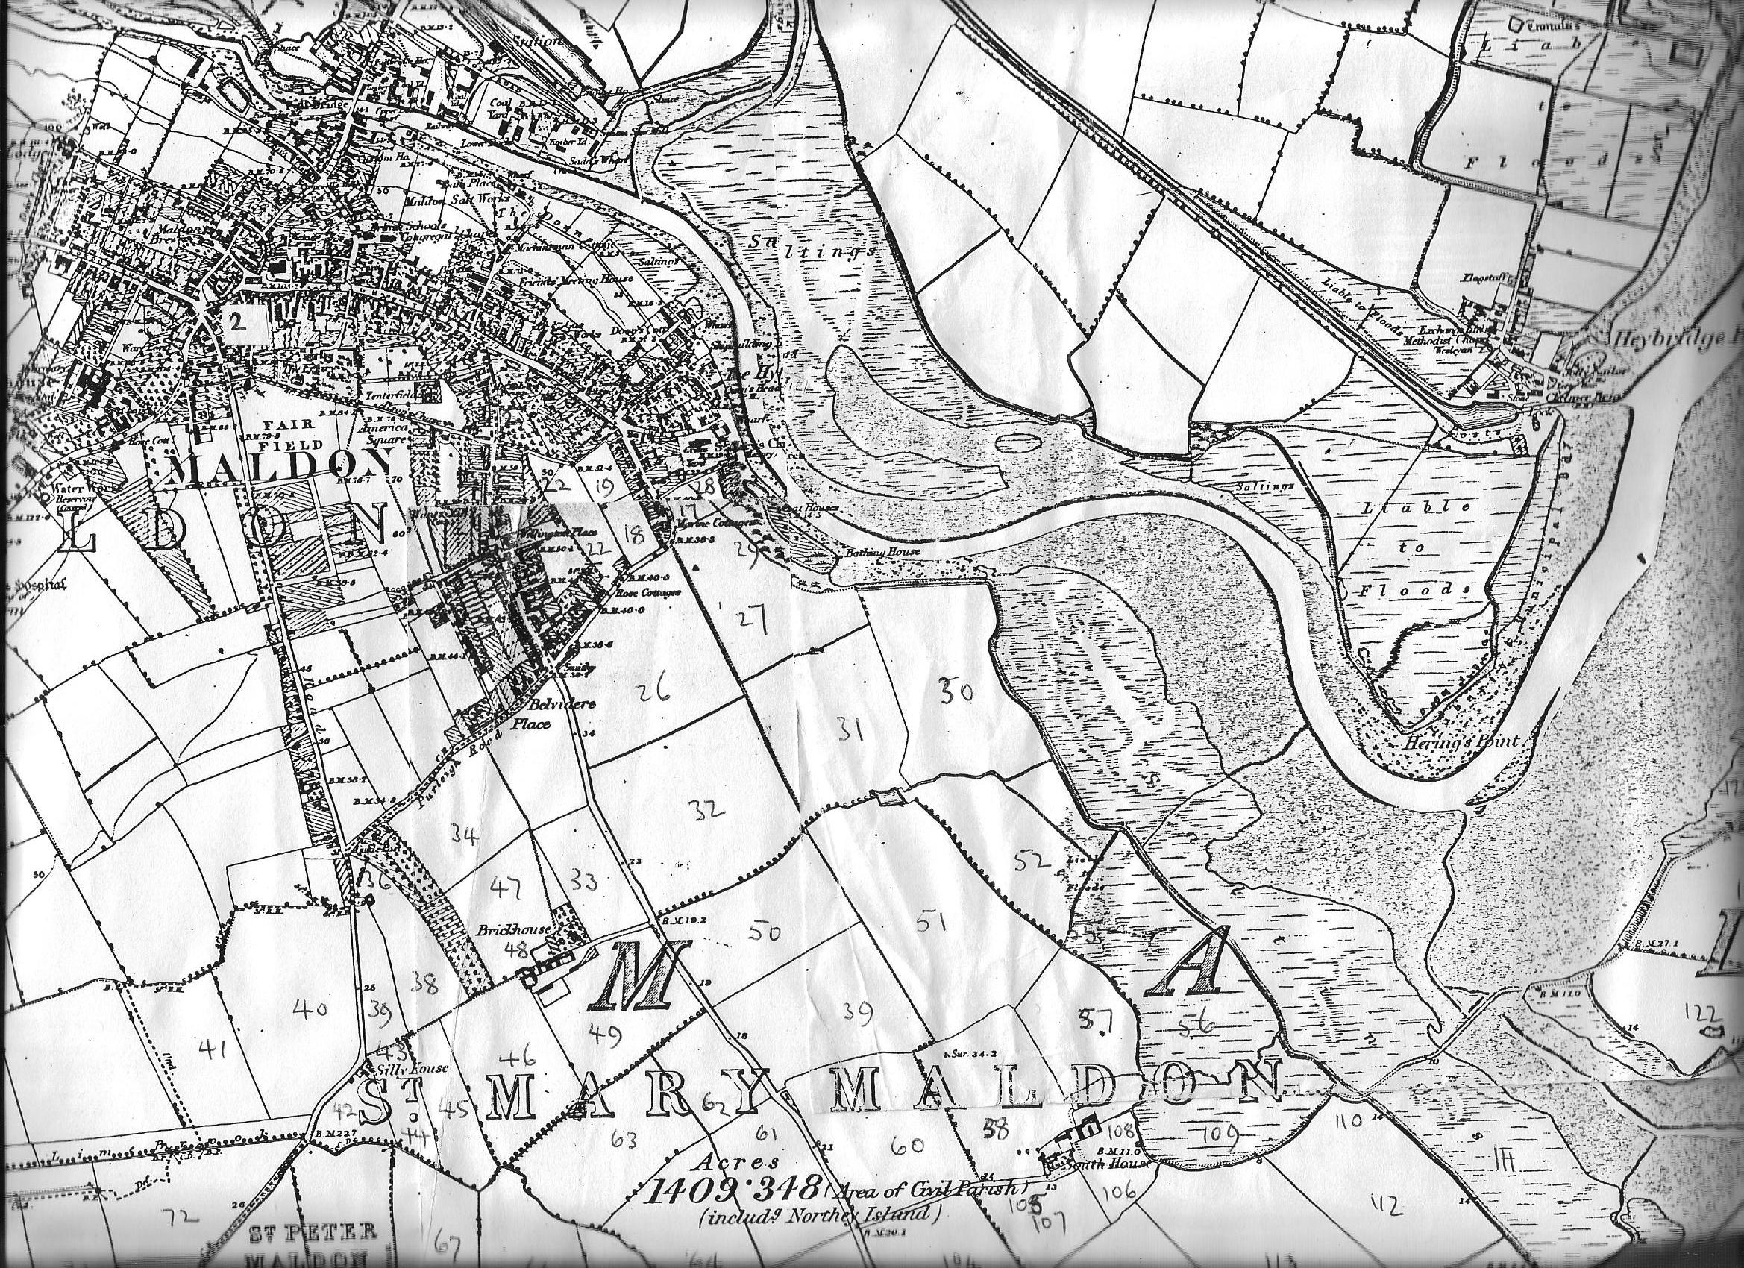
Map 1
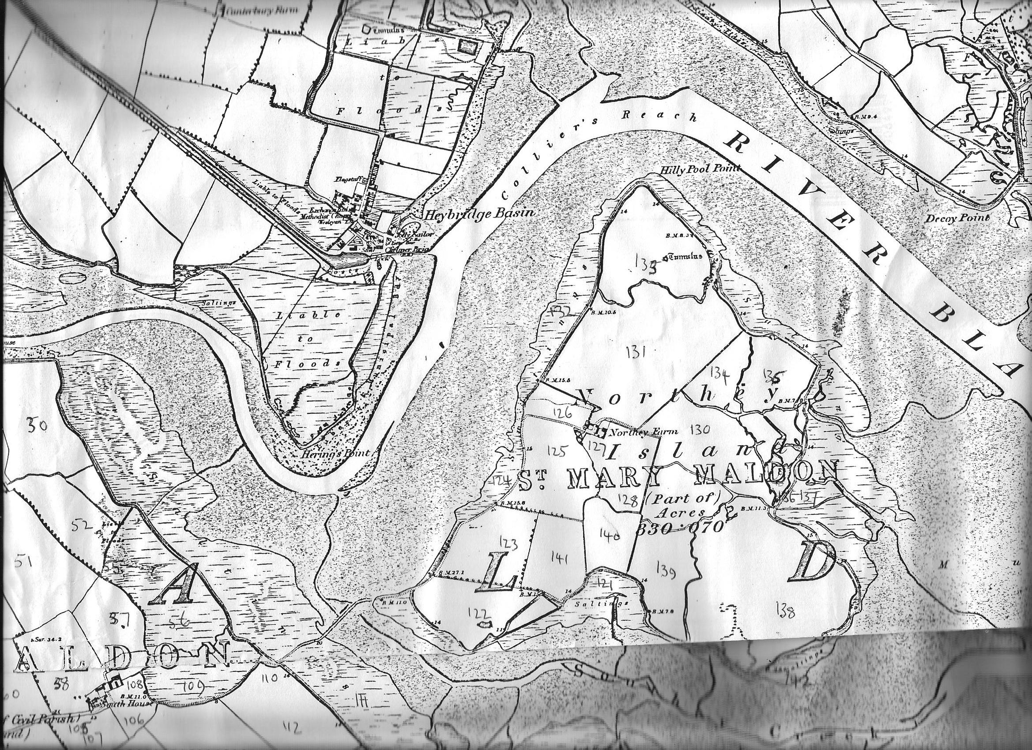
Map 2
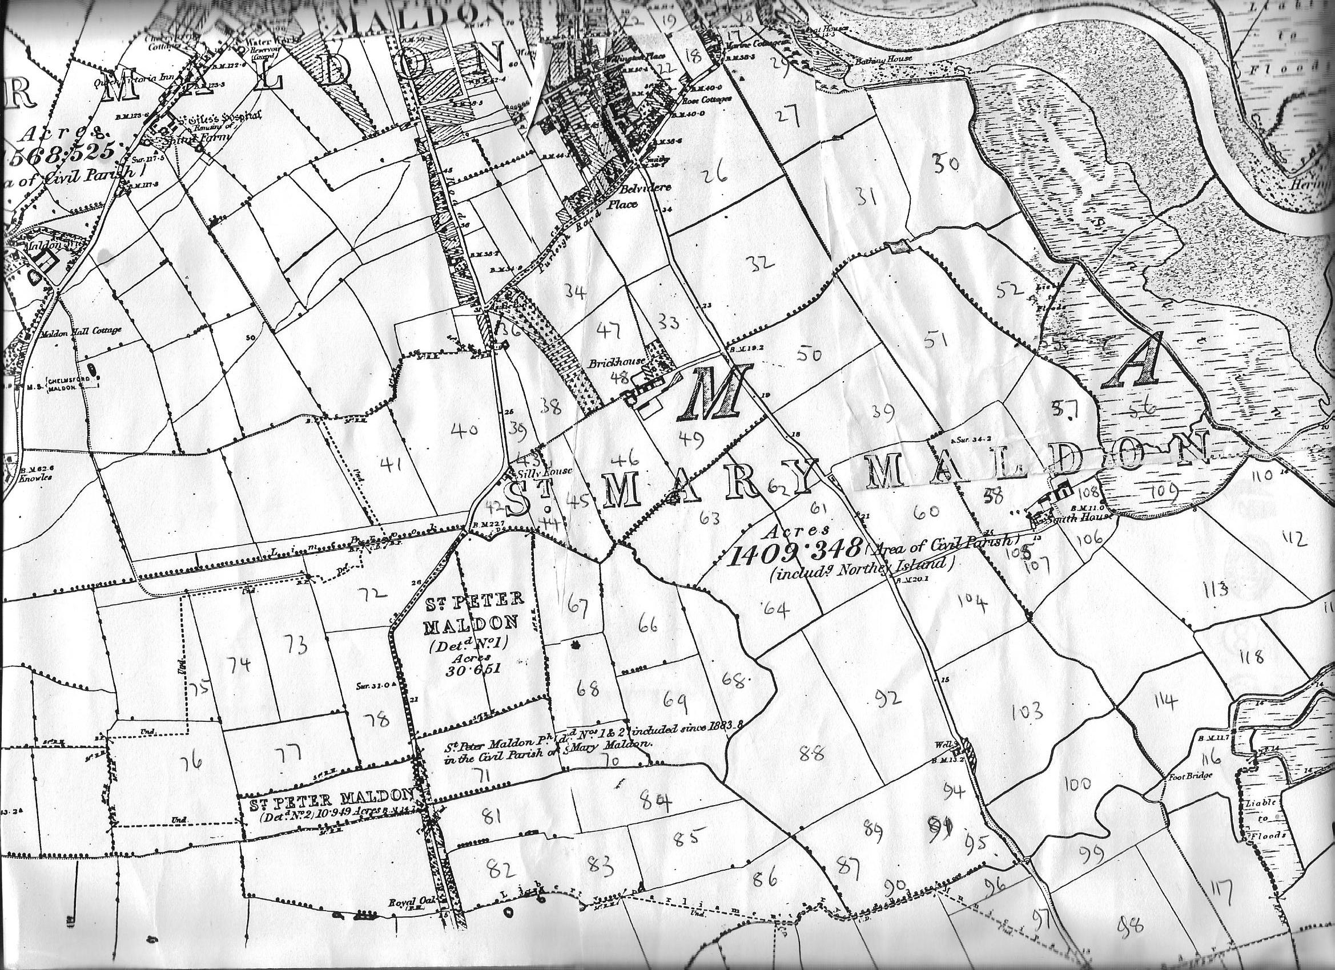
Map 3
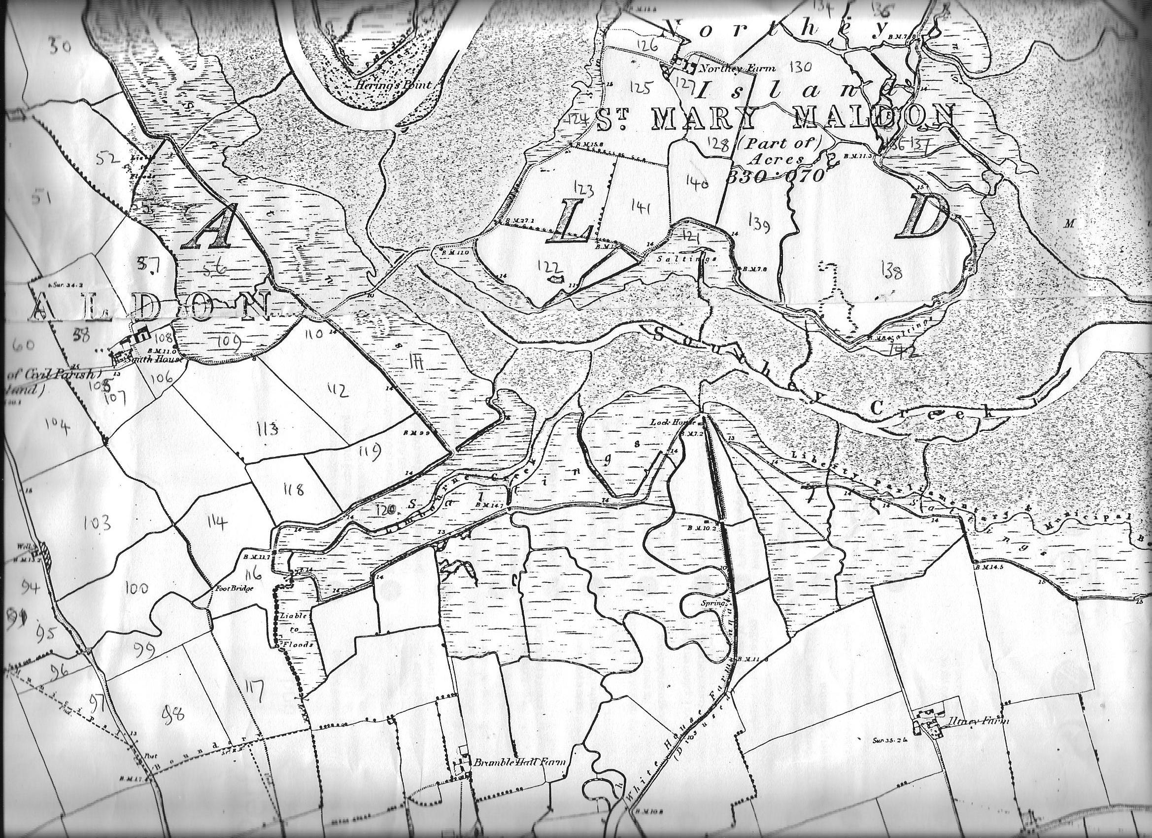
Map 4

